My name is Stephanie Michaelson. I am the prevention specialist for Broadwater County working under a federal block grant awarded to Butte Cares, Southwest Montana Prevention. Butte Cares started out as a non-profit organization in Butte. It has grown to now serve 12 counties with 20 employees in the Southwest region. This grant now provides a prevention specialist to help our youth sustain from substance use in our county.
We use a 7-step strategic prevention framework to:
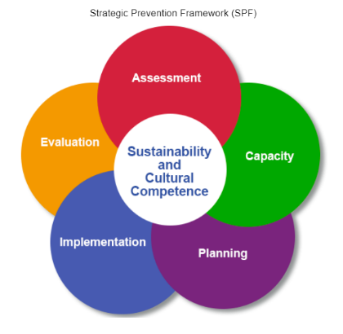
- Assess the needs of our community
- Build capacity
- Planning
- Implementation
- Evaluation
- Sustainability and Cultural Competence

Data shows that alcohol is still the drug of choice among our youth. Investing in prevention is cost effective. Depending on the programs and activities, evidence shows that for every dollar spent in prevention it has a cost ratio of $18-$20 downline costs. Funds are either spent now or more funds are spent later for treatment and other costs to the community because of alcohol and drug abuse. With the additional alcohol tax funds, we would be able to continue and sustain prevention efforts in Broadwater County.

For more information, please contact me at:
Stephanie Michaelson
Prevention Specialist
406-403-0044
bmprevent@swmtprevent.org
